Shadow Puppet Plays
张家港市外国语学校北区 展丹凤
I. Teaching aims and learning objectives
1. Understand how to make shadow puppet and put on a shadow puppet play;
2. Be able to retell how to make shadow puppet and how to put on a shadow puppet play;
3. Develop students’ reading abilities of skimming and scanning;
4. Cultivate students’ awareness of protecting the traditional art forms.

II. Teaching contents
1. New words and phrases: shadow, puppet, audience, object, movable, screen, character, ancient, traditional, put on a shadow puppet play, keep ... alive.
2. New structure: Shadow puppets are made of hard leather.
The leather is cut out in the shape of a person, an animal or an object.
Each puppet is painted in bright colours and put on a stick.

III. Focus of the lesson and predicted area of difficulty
1. Introduce how to make shadow puppets by using the passive voice;
2. Express one’s own opinions about how to keep traditional art forms alive.

IV. Teaching procedures
Step1 Pre-reading
- Watch a video about Shadow Puppet Plays.
T: Have you ever watched this kind of play? Do you know the name of this kind of play?
S: Shadow Puppet Plays
T: In the video, we can see some actors holding some puppets to give a show. We can also say
“The actors are putting on a shadow puppet play.”
T: Do you think it is modern?
S: No. It has a long history.
T: It is a traditional art form.
- Thinking: Why is it called Shadow Puppet Plays? Can we just call it puppet plays?

Step 2 While- reading
- Skim the article and find out the main idea of each paragraph.
Para 1 An introduction
Para 2 How to make shadow puppets
Para 3 How to put on a shadow puppet play
Para 4 The present situation(现状)
Para 5 Wang Weifang's opinion
- Read Para 1 again and think about the following questions.
- What does the word “audience” mean?
- Why is Xi’an mentioned?
- Why can’t the audience see Wang and his friends?
- Read Para 2
- Find out the materials & tools they need and the making process.
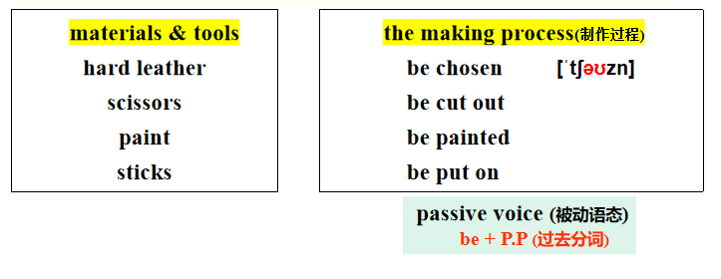
- Ask Ss to the phrases and introduce the passive voice.
T: When we don’t know or don’t need to know who does the actions, we can use the passive voice.
- Ask Ss to introduce how to make shadow puppets in their own words. Don’t forget to use
the passive voice.
- Further thinking: Why does the writer choose the three words?
( hard leather, bright colours; movable arms and legs)
- Read Para 3
- Find out the props and the steps to put on a play
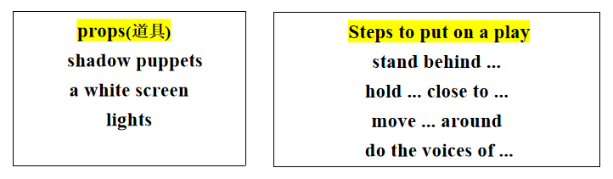
- Ask Ss to introduce how to put on a shadow puppet play in their own words.
- Read Para 4
- Ask a student to read Para 4.
- T: Why are shadow puppet plays not as popular as before?
S: Because of TV and films.
T: It is just one of the reasons. Can you think of more reasons? Please discuss in groups.
S: ......
- Read Para 5
- Ask a student to read Para 5
- If you were Wang Weifang, what would you do?
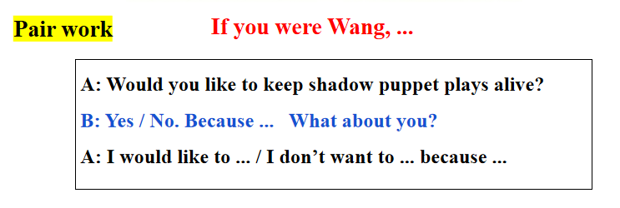
Step 3 Post- reading
- T: Beside shadow puppet plays, there are many other kinds of traditional art forms.
However, they are facing the similar problems. Let’s have a look.
- Watch a video and find out what problems the traditional art forms are facing.
- Discussion:
As a middle school student, what should we do to keep our traditional art forms alive?

Step 4 Homework
- Introduce shadow puppet plays to your parents.
- Write a report on how to keep traditonal art forms alive.

