Healthy eating doesn't just mean what you eat, but how you eat. Here is some advice on healthy eating.
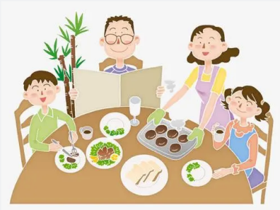
Eat with others. It can help you to see others’ healthy eating habits. If you usually eat with your parents, you will find that the food is more delicious.
Listen to your body. Ask yourself if you are really hungry. Have a glass of water to see if you are thirsty. Sometimes you are just thirsty and you need no food. Stop eating before you feel full.
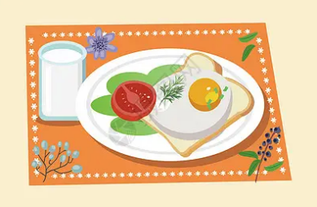
Eat breakfast. Breakfast is the most important meal of the day. After you don't eat for the past ten hours, your body needs food to get you going. You will be cleverer after eating breakfast.
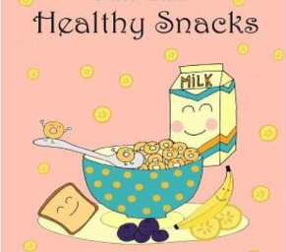
Eat healthy snacks like fruits,yogurt or cheese. We all need snacks sometimes. In fact, it's a good idea to eat two healthy snacks between your three meals. Vegetables are good choices. They are full of vitamins and minerals. But some people don't like eating vegetables. They think they are yukky.Fruits are also very good for the body. As the saying goes, "An apple a day keeps the doctor away." So don't forget to eat some fruit.
Don't eat dinner late. Try to eat dinner three hours before you go to bed.This will help your body to digest most of the food before you rest for the next 8-10 hours.

